**MY NOTES:**

ArrayList-10  
Vector-10  
HashSet-16  
HashMap-16  
HashTable-11

Compile time polymorphism(Method overloading) and runtime polymorphism(Method Overriding)

ConcurrentHashMap vs HashTable

ConcurrentHashMap Is newer. They both Thread safe and synchronized accept ConcurrentHashMap utilizes synchronize block technique so locking only portion of the object rather than the whole class is locked

UnsupportedOperationException

HashMap

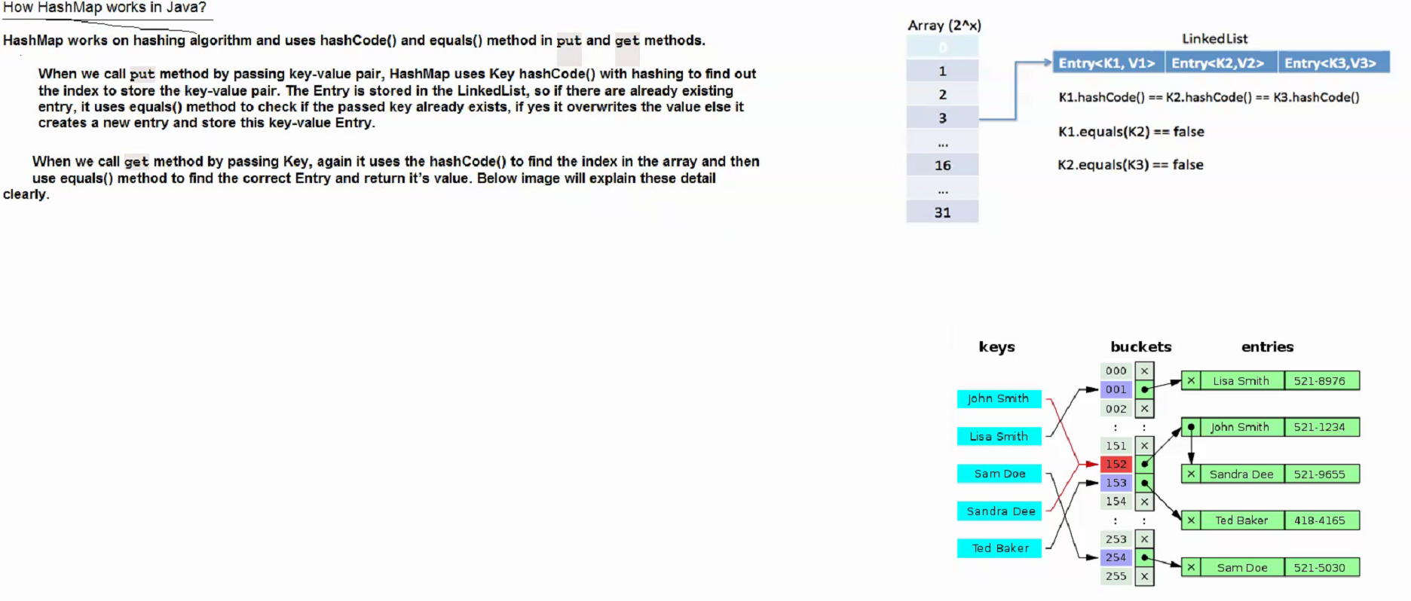

**CHAT NOTES:**

from Synergisticit Synergisticit to everyone:

How will you make Collections readOnly

from Synergisticit Synergisticit to everyone:

What is UnsupportedOperationException?

from Synergisticit Synergisticit to everyone:

This exception is thrown to indicate that the requested operation is not supported.Example of UnsupportedOperationException:In other words, if you call add() or remove() method on the readOnly collection . We know readOnly collection can not be modified . Hence , UnsupportedOperationException will be thrown.

from Synergisticit Synergisticit to everyone:

How HashMap works in Java?

from Synergisticit Synergisticit to everyone:

Hashtable vs HashMap in Java

from Synergisticit Synergisticit to everyone:

ConcurrentHashMap vs Hashtable-

from Synergisticit Synergisticit to everyone:

compile time polymorphism and run time polymorphism?

from Synergisticit Synergisticit to everyone:

ex-method overloading and overriding

from Synergisticit Synergisticit to everyone:

Difference between Exception and Error?

from Synergisticit Synergisticit to everyone:

● Both java.lang.Error and java.lang.Exception classes are subclasses of java.lang.Throwable class. java.lang.Error class represents the errors which are mainly caused by the environment in which application is running. For example, OutOfMemoryError occurs when JVM runs out of memory or StackOverflowError occurs when stack overflows. Where as java.lang.Exception class represents the exceptions which are mainly caused by the application itself. For example, NullPointerException occurs when an application tries to access null object or ClassCastException occurs when an application tries to cast incompatible class types. ● Recovering from Error is not possible. The only solution to errors is to terminate the execution. Where as you can recover from Exception by using either try-catch blocks or throwing exception back to caller.

from Synergisticit Synergisticit to everyone:

Hashtable vs HashMap in Java1)First and most significantly difference between Hashtable and HashMap are that HashMap is not thread-safe while Hashtable is a thread-safe collection.2) The second important difference between Hashtable and HashMap is performance since HashMap is not synchronized it perform better than Hashtable.3)The third difference on Hashtable vs HashMap is that Hashtable is obsolete class and you should be using ConcurrentHashMap in place of Hashtable in Java.4)HashMap allows one null key and values while HashTable does not.5)HashMap provides Set of keys to iterate and hence it’s fail-fast but Hashtable provides Enumeration of keys that doesn’t support this feature.

from Synergisticit Synergisticit to everyone:

ConcurrentHashMap vs Hashtable-Both are thread safe.Hashtable is a legacy class from JDK 1.1 itself, which uses synchronized methods to achieve thread-safety. All methods of Hashtable are synchronized which makes them quite slow due to contention if a number of thread increases.On the other hand, ConcurrentHashMap is specially designed for concurrent use i.e. more than one thread. By default it simultaneously allows 16 threads to read and write from Map without any external synchronization. It is also very scalable because of stripped locking technique used in the internal implementation of ConcurrentHashMap class. Unlike Hashtable and Synchronized Map, it never locks whole Map, instead, it divides the map into segments and locking is done on those.

from Synergisticit Synergisticit to everyone:

What is UnsupportedOperationException? This exception is thrown to indicate that the requested operation is not supported.Example of UnsupportedOperationException:In other words, if you call add() or remove() method on the readOnly collection . We know readOnly collection can not be modified . Hence , UnsupportedOperationException will be thrown.

from Synergisticit Synergisticit to everyone:

How will you make Collections readOnly General : Collections.unmodifiableCollection(Collection c) Ex- Collections.unmodifiableMap(Map m)Collections.unmodifiableList(List l)Collections.unmodifiableSet(Set s)

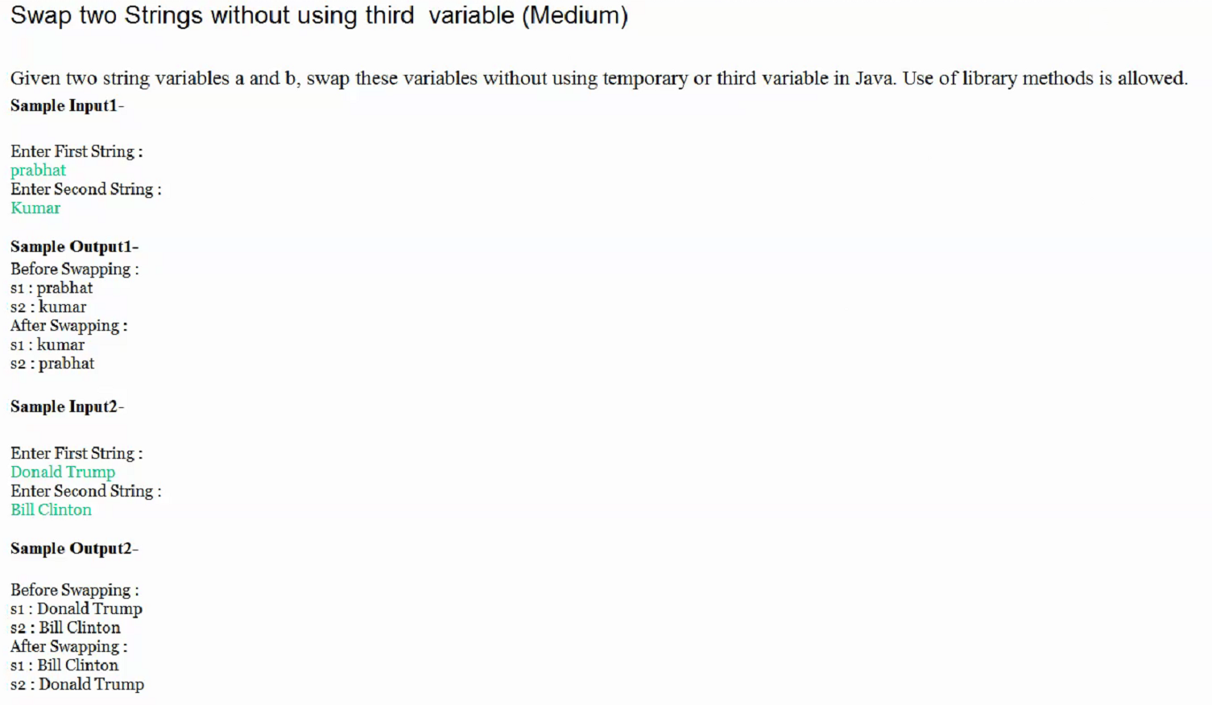

My turn Study MultiThreading

